NHS app – Step by step instructions

The NHS App is a simple and secure way to access a range of services on your smartphone or tablet. It is free from app stores. You need to be 16 or over to use the NHS COVID Pass service and registered with an NHS GP practice in England.
The NHS App should not be confused with the NHS COVID-19 App which offers the fastest way to see if you’re at risk from coronavirus.
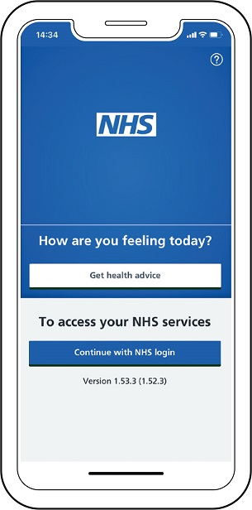
Use the NHS App to:
- get your NHS COVID Pass - view and share for domestic use or travel abroad
- order repeat prescriptions
- book appointments
- get health advice
- view your health record
- register your organ donation decision
You will need a working mobile phone and email address to be able to create a login.

Installing
Downloading the NHS App on a mobile device:
- Open the App Store or Play Store.
- Search for ‘NHS App’ and select install.
- After installing, select the app to open it.

- Registration
Registering onto the NHS App on a mobile device:
- Enter your email address and select ‘Continue’.
- Select ‘Continue’ to set up a new NHS login.
- To create an account you will need to know your NHS number or name, date of birth and postcode. Select ‘Continue’ if you know this information.
- Create a password and select ‘Continue’.
- A code will be sent to your email address to confirm who you are.
- Enter your mobile number. You will be sent a security number via text to confirm your mobile number.
- Once your registration is complete, you will be asked if you are happy to share your details from your GP Surgery with the NHS App – choose ‘Yes’ or ‘No’ and select ‘Continue’.
- Then you are asked to agree to the NHS terms of use, privacy policy and cookie policy (the cookie policy is optional)
- Prove who you are
Confirming your identity:
- Take a photo of your ID and submit photo of ID (passport, driving license)
- Next you will be asked to record a short video of your face as you say four randomly generated numbers.
- You will then be asked to enter your date of birth.
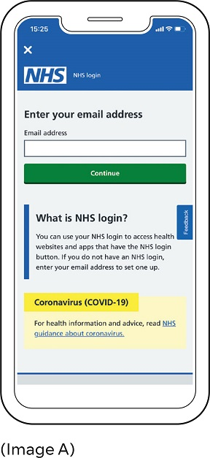
- Once all the above is completed, you can expect to hear confirmation within 2-24 hours.

Logging in

Logging into the NHS App on a mobile device:
- Enter your email address and select ‘Continue’ (Image A to the right).
- Enter your password.
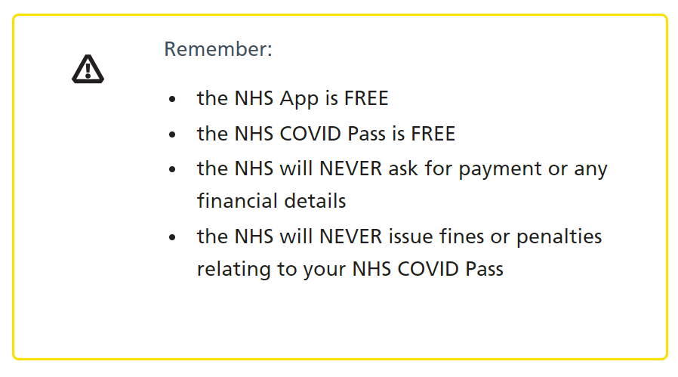

Video tutorial for setting up the app - NHS login - patient journey - YouTube
For NHS app information and support please follow this link - NHS App and your NHS account - NHS (www.nhs.uk)

